**Design of experiment and data analysis Tutorial 3 Class work**

**Sample calculations in t-SNE**

**Computation step 1: Calculation of distance matrix in high dimension:**

**Paper and pencil exercise:** Calculate the distance matrix and show the calculation in details for one calculation. What is the dimension of the distance matrix?

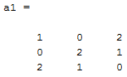

**Calculate the distance matrix:**

**Python Code:**

from scipy.spatial.distance import cdist

#D1 is the high dimensional numpy array

# Calculate distance matrix using Euclidean distance

dist_matrix = cdist(D1, D1, metric='euclidean')

print(dist_matrix)

**Computation step 2: Calculation of similarity (joint probability) in High dimension: [P(i,j)]** Suppose the following is the matrix for 6 points for high dimension data (n dimension). Calculate the conditional probability and then joint probability matrix/similarity matrix. With **sigma =1.00**

**Code hints for the High dimensional matrix are shared, try to replicate it with low dimensional matrix.**

**## Import the libraries**

import pandas as pd

import numpy as np

import matplotlib.pyplot as plt

import seaborn as sns

from scipy.spatial.distance import cdist

**## Load the data**

data3 = [[0.000, 2.000, 1.998, 1.181, 1.812, 1.993],

        [2.000, 0.000, 1.999, 1.216, 1.795, 1.996],

        [1.998, 1.999, 0.000, 1.258, 1.772, 1.998],

        [1.181, 1.216, 1.258, 0.000, 0.208, 1.326],

        [1.812, 1.795, 1.772, 0.208, 0.000, 1.732],

        [1.993, 1.996, 1.998, 1.326, 1.732, 0.000]]

data3 = np.array(data3)

sns.heatmap(data3)

**## Calculate the distance matrix**

dist_matrix3 = cdist(data3, data3, metric='euclidean')

## **Calculate the conditional probability**

def sim(dist):

    return math.exp(-(dist)**2/2)

def cond_prob(j,i,dist_mat):

    # i and j are shapes of the matrix, in python indexing starts from 0 so we need to subtract 1

    i = i-1

    j = j-1

    # We are calculating the numerator for the conditional probability

    num = sim(dist_mat[i,j])

    # We are calculating the denominator for the conditional probability

    if i ==j:

        return 0 # Refer the formula

    else:

        den = 0

        for col in range(np.shape(dist_mat)[1]): # We are iterating over the columns

            if col != i:

                den += sim(dist_mat[i,col])

        return num / den # Returning the conditional probability

print('The conditional probability of i=1 and j=3 is: ',cond_prob(3,1,dist_matrix3))

print('The conditional probability of i=3 and j=1 is: ',cond_prob(1,3,dist_matrix3))

# Check are the probabilities different or same, refer literature to find out if you are correct?

**## Calculate the joint probability:**

def joint_prob(dist_matrix,data):

    # Our conditional matrix will be of same shape as of the distance matrix

    cond_matrix = np.zeros(np.shape(dist_matrix))

    row, colm = np.shape(data)

    m,n = np.shape(dist_matrix)

    # We are iterating over the rows and columns to find out the conditional probability for each pair

    for i in range(1,m+1):

        for j in range(1,n+1):

            cond1 = cond_prob(j,i,dist_matrix)

            cond2 = cond_prob(i,j,dist_matrix)

            # Refer the formula

            temp = (cond1 + cond2)/(2*row*colm)

            # Storing the value in the conditional matrix

            cond_matrix[i-1,j-1] = temp

    return cond_matrix

joint_prob_data3 = joint_prob(dist_matrix3,data3)

print('The high dimensional Matrix is: ')

print(np.round(data3,3))

print(data3.shape)

print('\nThe joint probability of high dimension matrix is: \n\n',np.round(jp_hig_dim,4))

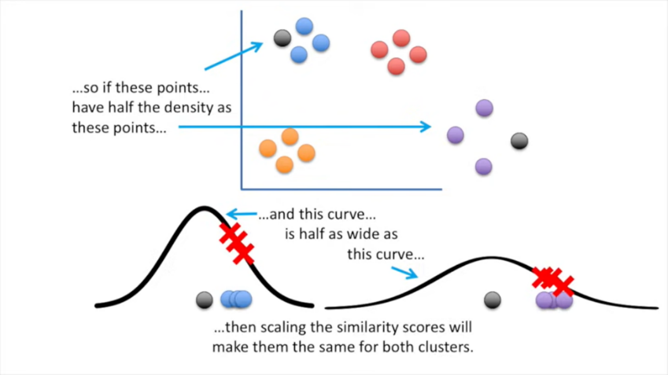

**Now we are assuming we have a reduced dimension matrix of our data, we will initialize a random matrix of 10 data points and 2 dimensions. We will later make this matrix as close as possible to the high dimension matrix by using Gradient Descent.**

**Initialization of 2 dimensional matrix:**

#Calculation of joint probability for low dimension matrix

#############################

#Code to generate the random number matrix

np.random.seed(0)

Y = np.random.rand(6,2)

print('The high dimensional Matrix is: ')

print(np.round(data3,3))

print(data3.shape)

print('\n\nThe low dimensional Matrix is: ')

print(np.round(Y,5))

print(Y.shape)

**Do it yourself:**

**Computation step 4: Calculation of distance matrix of the above low dimension matrix (guess value)**

**Computation step 5: Calculation of the conditional probability, and similarity (joint probability) in low dimension from the above distance matrix.**

**Computation step 6: Calculate the KL divergence betwen the joint probabilities for the first iteration.**

def kl_divergence(P, Q):

    """Compute the KL divergence between joint probability matrices P and Q."""

    epsilon = 1e-8  # Small value to avoid division by zero

    P = np.clip(P, epsilon, None)

    Q = np.clip(Q, epsilon, None)

    kl_div = np.sum(P * np.log(P / Q))

    return kl_div

**Computation step 7: Set a code for gradient descent algorithm to minimize the KL divergence between P and Q, the joint probability of high and low dimension matrix:**

$$Loss function=\sum_{i}{KL\left(P_{i}∥Q_{i}\right)}=\sum_{i}{ }\sum_{j}{p_{ij}log\frac{p_{ij}}{q_{ij}}}$$

$$Y^{(t)}=Y^{\left(t-1\right)}+η\frac{δC}{δY}+α(t)(Y^{(t-1)}-Y^{(t-2)})$$

$$\frac{δC}{δy_{i}}=4\sum_{j}{(p_{ij}-q_{ij})(y_{i}-y_{j}) }{(1+∥y_{i}-y_{j}∥^{2})}^{-1}$$

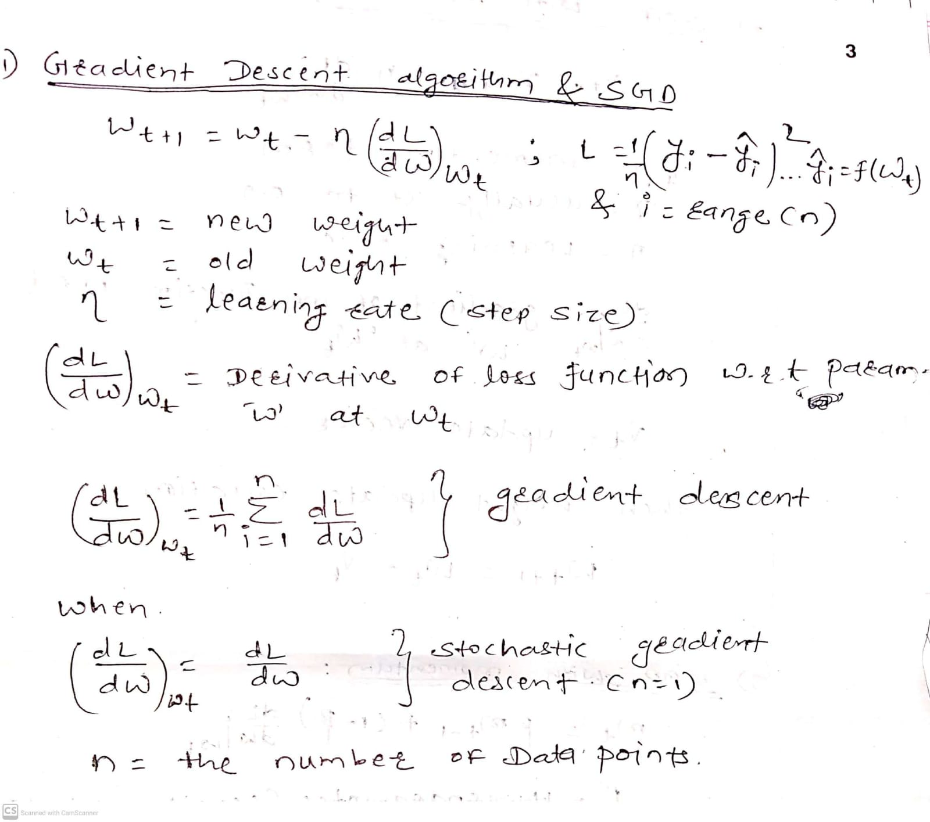

**Code Hints:**

**Minimize KL Div. loss for two normal distributions. From this code you will learn how to use gradient descent in pytorch, and use it on a matrix. Here your parameter which is being optimized is a matrix.**

**(Modify the code to apply for the given matrices in TSNE)**

# Learning to optimize the KL divergence of two probability distributions one is known and another is randomly generated

import numpy as np

import matplotlib.pyplot as plt

from scipy.stats import norm

#from scipy.stats import entropy as kl_divergence

def kl_divergence(p, q):

    return np.sum(np.where(p != 0, p * np.log(p / q), 0))

x = np.arange(-10, 10, 0.01)

#mean = 0, standard deviation = 2

p_pdf = norm.pdf(x, 0, 2 )

#Generate a random mean, random standard deviation and random pdf

np.random.seed(32)

random_mean = np.random.randint(10)

random_std = np.random.randint(10)

q_pdf = norm.pdf(x, random_mean, random_std)

plt.plot(x, p_pdf, label='p(x)')

plt.plot(x, q_pdf, label='q(x)')

plt.legend()

plt.show()

print('The KL Divergence between the two distributions is: ',kl_divergence(p_pdf, q_pdf))

import torch

learning_rate = 0.001

epochs = 1000

# In pytorch we need to define the variables which will be optimzed after gradient calculation

# Formula for normal distribution is given by: 1/(std*sqrt(2*pi)) * exp(-0.5*((x-mean)/std)**2)

x = torch.arange(-10, 10, 0.01, dtype=torch.float)

p = torch.tensor(p_pdf, dtype = torch.float)

mu = torch.tensor(4, requires_grad=True, dtype = torch.float)

std = torch.tensor(6, requires_grad=True, dtype = torch.float)

#Mean is initialized with 4 and standard deviation is initialized with 6

#Define Optimizer

optimizer = torch.optim.SGD([mu, std], lr = learning_rate)

epoch_count = []

loss_count = []

mean = []

variance = []

for epoch in range(epochs):

    q_pdf = torch.exp(-torch.square(torch.tensor(x) - mu) / (2 * std**2)).type(torch.float)

    q = q_pdf / torch.sum(q_pdf)

    kl_div = torch.sum(p * torch.log(p / q))

    optimizer.zero_grad()

    kl_div.backward()

    optimizer.step()

    epoch_count.append(epoch)

    loss_count.append(kl_div.item())

    mean.append(mu.item())

    variance.append(std.item())

plt.figure(figsize = (12, 4))

plt.subplot(1, 3, 1)

plt.plot(epoch_count, loss_count)

plt.xlabel('Epochs')

plt.ylabel('Loss')

plt.title('KL Divergence Loss')

plt.subplot(1, 3, 2)

plt.plot(mean, label=f'Current Mean: {np.round(mu.item(),2)}')

plt.axhline(y=0, color='r', linestyle='--', label='Actual: 0')

plt.title('Mean, Actual Mean: 0')

plt.legend()

plt.subplot(1, 3, 3)

plt.plot(variance, label=f'Current Var: {np.round(std.item(),2)}')

plt.axhline(y=2, color='r', linestyle='--', label='Actual: 2')

plt.title('Variance')

plt.legend()

plt.show()

